CURRICULUM VITAE
Name Johannes (Jos) DOUMA  Born Groningen, 10 January 1955  Marital status Married to Aleid BOLHUIS | 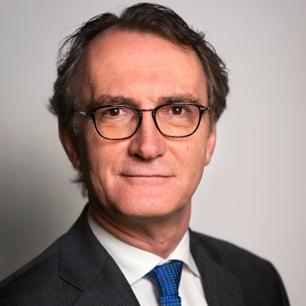

Education 1972 HBS B
1979 Groningen University (History)

Current position Ambassador of the Netherlands to Georgia and Armenia
(since September 2015)

Previous positions 2013 – 2015 Ambassador of the Netherlands to the Islamic Republic of Iran
2009 – 2013 Ambassador of the Netherlands to the Republic of Slovenia
2010 – 2011 Chargé d’Affaires to the Holy See
2005 – 2009 Deputy Head of Mission at the Embassy of the Kingdom of the Netherlands in Moscow
2001 – 2005 Head of Department Central Europe and Deputy Director Western and Central Europe directorate, Ministry of Foreign Affairs, the Netherlands
2000 – 2001 Head of Department Central Europe, Ministry of Foreign Affairs, the Netherlands
1996 – 2000 Head of Matra programme (Programme for Social Transformation in Central and Eastern Europe), Europe Directorate, Ministry of Foreign Affairs, the Netherlands
1980 – 1996 Joined the Ministry of Foreign Affairs in The Hague, and was posted at the Embassy of the Kingdom of the Netherlands in respectively Harare, Lagos and Bonn and at the Ministry in The Hague

